7.64: If the speed of the rock at the top is v_{t}, then conservation of energy gives the speed 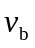 from 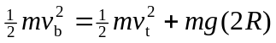, R being the radius of the circle, and so 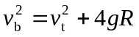. The tension at the top and bottom are found from 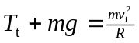 and 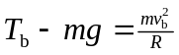, so .

